Changes Between APA 6th and APA 7th Editions

Please take the time to familiarize yourself with the following changes between the 6th and 7th editions.
Seventh edition (2019) | Sixth edition (2010)
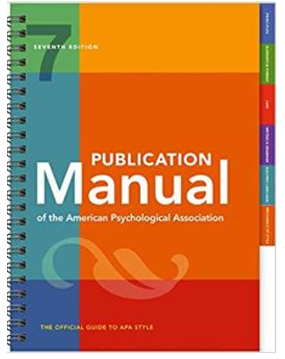 | 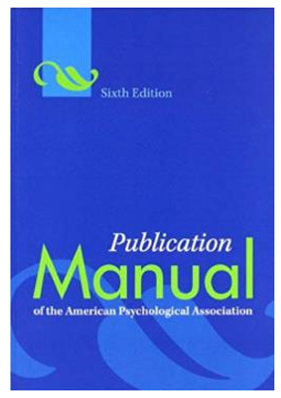
Mechanics of Style / Writing & Grammar
Singular ‘they’ is acceptable (Section 4.18, p. 120) | Pronouns: ‘He or she’ or plural ‘they’ (Section 3.20, p. 79)
Single space after all punctuation (Section 6.1, p. 154) | Two spaces after punctuation (Section 4.01, p. 88)
Editorial ‘we’ is not permitted (Section 4.17, p. 120) | Editorial ‘we’; No specific guideline
Spelling  - ebook  - webpage  - internet  - Wi-Fi  (Section 6.11, pp. 161-162) | Spelling  - ebook  - webpage  - internet
Capitalize all nouns followed by numerals or letters, except pate (p. or pp.) and paragraph (para. or paras.). Section is now capitalized (Section) (Section 6.19, p. 168) | Capitalize nouns followed by numerals or letters, except common parts of books, sections, tables, page (p. or pp.) and paragraph (para. or paras) (Section 4.17, p. 103)
Abbreviate hour, minute, second, millisecond, etc., when followed by a numeric value (Section 6.28, p. 178) | No guideline
Use numerals to express all units of time, including approximations (Section 6.32, p. 178) | Use numerals to express units of time except when time is an approximation (Section 4.31, pp. 111-112)
Use of double quotation marks has been expanded to include copyright attribution (Section 6.7, p. 158) | Use double quotation marks to introduce invented terms or text used ironically, to set off titles in text, and to denote quotes (Section 4.07, pp. 91-92)
Citing Material
Use ‘Author et al.’ when citing work by three or more authors (Table 8.1, p. 266) | Use ‘Author et al.’ when citing work by six or more authors (Ta le 6.1, p. 177)
References by the same author with the same publication date include a lowercase letter after the year and are organized by year-letter (Section 8.19, p. 267) | References by the same author and publication date are arranged by alphabetically by title unless they are part of a series. Use lowercase letters after the year (Section 6.21, p. 182)
References Entries
Italicization has been expanded to include titles of webpages (Section 6.22, pp. 170-171) | Titles of books, journals, magazines, newspapers, and stand-alone publications are set in italics (Section 4.21, p. 104)
Include up to 20 authors, For 21 authors and more, list the first 19 plus the last one (Section 9.8, p. 286) | In works with more than seven authors, include the first six plus the last one (p. 198, Example 2)
For multiple group authors, use the most specific agency as the author (Section 9.11, p. 288) | For multiple group authors, list all agencies from largest to smallest as the author (Section 7.03, p. 205, Example 31)
Always include a publication’s issue number (Section 9.25, p. 294) | Include a publication’s issue number only when the publication is paginated by issue (Section 6.30, p. 186)
For sources from journals, magazines, newspapers, and blogs, finish the reference entry with a DOI or URL as applicable. ‘Retrieved from’ is no longer in use. For database sources, the page range is the last item of the entry (Section 9.25, p. 294) | For sources from journals, use the DOI if it has been assigned one. If not, use ‘Retrieved from’ and the exact URL for the journal home page for sources accessed through a database (Section 6.32, pp. 1890192, and Section 7.01, p. 198)
Include article numbers as ‘Article xxxx’ (Section 9.27, p. 294) | No guideline
Publisher’s location is no longer in use (Section 9.29, p. 295) | For books and reports give the publisher’s location (Section 6.30, pp. 186-187)
DOIs and URLs are presented as live links (Section 9.35, p. 299) | No guideline
The only accepted format for DOIs in reference entries is https://doi.org/xxx (Section 9.35, p. 299) | Format DOIs in reference entries as doi:xxx, http://dx.doi.org/xxx, or https://doi.org/xxx
Long DOIs and URLs can be shortened (Section 9.36, p. 300) | No guideline
Italicize titles of social media content, online forum posts, and webpages (Sections, 10.15-10.16, pp. 348-352) | No guideline

