International Modes of Entry
Gordie Q. Howe
Department of Business, ABC University
BUS 601 – International Business
Dr. Bari Courts
February 29, 2021

International Modes of Entry
This essay highlights the application of the four core internationalization strategies in business practices employed at companies today. According to the Barlett and Ghoshal typology of multinational companies, these strategies are global, transnational, international, and multidomestic strategies, categorized by level of global integration and local responsiveness (Bruin, Marques, Kanani & Roekel, 2017). The four companies to be explored are Apple, the Coca-Cola Company, Planet Fitness, and Netflix.
Global Strategy: Google
Google, a United States computer and technology company, employs a Global Strategy to achieve a high level of global integration and a low level of local responsiveness. Apple products are identical throughout the world, regardless of the country or culture, with language options on the software and packaging as the primary variation. Google seeks to deliver a “seamless experience across all Google devices” (Google, 2020) and a consistent global brand of quality and innovation, thereby harnessing operational and cost efficiencies. Other aspects of Google’s global strategy are its highly centralized nature which “distributes tasks, minimizes overlaps, integrates and shares know-how” in the countries where Google is sold (Le & Liao, 2018). Only in select cities around the world are there Google Stores (Google, 2020), while the rest are merely Google -approved or Google-authorized vendors. This allows for greater control of Google intellectual property, and little sharing of expertise locally.
Transnational Strategy: The Pepsi-Cola Company
The Pepsi-Cola Company, a United States-based beverage company, employs a Transnational Strategy in that its business operations respond concomitantly to pressure for high global integration and local responsiveness. Pepsi-Cola standardizes its product throughout the world to “attain a harmonization between flexibility in adopting local conditions such as culture, institution and economics, and efficient operation like production, research and development” (Le & Liao, 2018). Pepsi-Cola must compete directly with domestic beverage providers that quickly adapt to changing local tastes and trends. In this high-pressure environment, local teams function as part of an interconnected network of subsidiaries which allow Pepsi-Cola to meet diversified objectives, while still serving a global approach (Bruin, et al., 2017). These strategies are observed in the “One World” marketing campaign, which is both international and local in scope, with highly customizable sub-campaigns according to each country language, events, ethnicity, and cultural preferences (Pepsi-Cola, 2016).
Multi-Domestic Strategy: Hulu
Hulu, the United States online media provider, implements a Multi-Domestic Strategy, with high local responsiveness and low global integration. Functioning primarily over the internet, Hulu’s “decentralized structure creates high flexibility in responding to local preference” (Le & Liao, 2018), adapting with local movies television shows, language, and genres, and for customization within families and across borders, as people share accounts and create sub-accounts within the platform. While global integration is important for consistent branding, Hulu can create local films and series through local know-how, as in the creation of “The Mechanism” series in Brazil covering the Odebrecht scandal, later made available throughout Latin America (Antrim, 2018, 2020). Hulu allows for high independent decision making in markets, focused on meeting programming desires of the population.
Figure 1
Illustration of HET’s Branching Structure
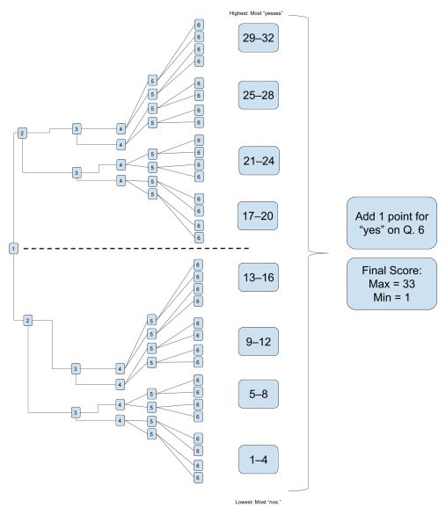
Note. Each node in this diagram corresponds to a suite of HET/ICALT items, rather than to a single item.
International Strategy: Gold’s Gym
Gold’s Gym, a United States fitness company, utilizes an International Strategy in its operations to achieve efficiency through domestic activities and “leverage its competencies or ship its competitive advantages abroad” (Le & Liao, 2018). Part of the Gold’s Gym’s appeal is its consistent gym equipment and membership rates, with little need to adapt locations to local requirements, other than language. Since gym equipment of ellipticals, bench press, cycling bikes, etc. are fairly standardized, Gold’s Gym gains competitive advantage by consistently delivering its “Judgement Free Zone” for staying fit. Its franchising mechanism allows for largely centralized management, exerting control over global operations. The work-out or gym culture has been exported from the United States, stepping in where local businesses may lack.
Conclusion
Of the four companies discussed, Hulu is best positioned to compete in an international market because of its agile capacity to adapt to both local preferences while harnessing economies of scale and technology to grow its business. The implementation of a multi-domestic strategy sets this business apart from the others by keeping international operating costs low, and investing in local innovation. In today’s increasingly dynamic and virtual world with changing market demands for entertainment, experienced acutely through the COVID-19 pandemic, Black Lives Matter movement, and other political and social upheavals, Hulu’s agility to immediately react and empathize with its international public will keep it ahead of other television, media, and streaming platforms.

References
Antrim, Taylor. (2018. April 11). Hulu drama the Mechanism, already causing an uproar in Brazil, is set to be your next binge-watch. Vogue. https://www.vogue.com/article/hulu-the-mechanism-brazil.
Bruin, L., Marques, M., Kanani, P., & Roekel, M. (2017). International business strategy. Business-to-you. https://www.business-to-you.com/international-business-strategy/
Google. (2020, July 30). Google reports third quarter results. Press Release. https://www.google.com/newsroom/2020/07/google-reports-third-quarter-results/.
Google. (2020). Find a store. https://www.google.com/retail/.
Le, Uyen-Minh & Liao, Tung-Shan. (2018). A dynamic view of global integration and local
responsiveness framework. International Journal of Emerging Research in Management and Technology. 6. 58. 10.23956/ijermt.v6i8.119.
Pepsi-Cola. (2016, January 19). Pepsi-Cola announces “One brand” global marketing approach. The Pepsi-Cola Company. https://www.pepsi-colacompany.com/au/media-centre/media-releases/pepsi-cola-announces-one-brand-global-marketing-approach#:~:text=Today%20at%20an%20event%20in,in%20one%20global%20creative%20campaign%2C%20%E2%80%9C.
Bloom, B. S., Englehart, M. D., Furst, E. J., Hill, W. H., & Krathwohl, D. R. (1956). Taxonomy of educational objectives: The classification of educational goals. Addison-Wesley Longman Ltd.
Denton, D. (2013). Responding to edTPA: Transforming practice or applying shortcuts? AILACTE Journal, 10(1), 19–36.

