STRATEGIES FOR INTERNATIONALIZATION

A company that operates in multiple nations is known as a multinational corporation (MNC). A A number of the world’s largest multinational companies have annual revenues larger than many countries. In 2016, Wal-Mart boasted an annual revenue of $482 billion (Gerencer, 2016), making it larger than the entire economies of Thailand, United Arab Emirates, or South Africa (World Development Indicators database, 2018). While much of the world thinks of Wal-Mart as an American retailer, over twenty five percent of its earnings are generated in foreign markets. Walmart owns significant numbers of stores, as of 2018, in Mexico (2358), Central America (778), United Kingdom (642), Brazil (465), China (443), Africa (424), Canada (410), Chile (378), Japan (336), Argentina (106) and India (110) (Total number of stores of Walmart International in 2018, by country, 2018). Even more moderately sized multinational companies are very influential. If Korean car manufacturer, Kia, were a country, its total sales in 2017 of $47.3 billion (Kia Motors, 2018) would make it the 86th largest country in the world.

Kia certainly chose a very appropriate name for itself – meaning “to rise up or come out of Asia” and the company has done just that. Founded in 1944 as a manufacturer of bicycle parts, Kia has established itself as a worldwide force in the automobile industry, producing over 2.1 million vehicles in eight countries in 2011 and selling them in 172 countries globally. Hyundai, a South Korean competitor, owns a 33% stake in Kia. Collaboration between these two corporations has bolstered the position of each. Kia’s slogan – The Power To Surprise – seems aptly chosen as competitors should be wary of what surprises this upstart might be prepared to unleash upon the auto industry in coming years (Edwards, n.d.).
Both Wal-Mart and Kia have selected strategies that they believe will guide them to success in their respective global industries.

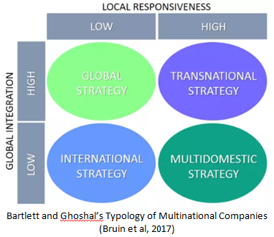
There are four main strategies adopted by MNC’s when operating their global businesses. An oft used framework for categorizing these different clusters of businesses is the Bartlett and Ghoshal Matrix (1989). This schema groups companies based on two criteria – global integration and local responsiveness. Businesses with a high level of global integration are focused on reducing costs by producing products and services with little to no variation, thus creating economies of scale. Firms who operate with sensitivity to local responsiveness tailor their product to meet the preferences of the local consumer.

There are four core internationalization strategies from which firms craft their path (Bruin, Marques, Kanani & Roekel, 2017).

International
Global
Multi-domestic
Transnational

Each of these strategies are paths leading toward the same destination – to build efficiency across nations, while simultaneously retaining the ability to exercise flexibility in accordance to market conditions and local customer preferences (Edwards, n.d.). Let us take a moment to explore each of these strategies individually.

Multi-domestic Strategy
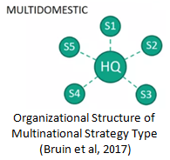
A multi-domestic strategy places an emphasis on responding to local preferences while sacrificing a modicum of efficiency to cater to these regional desires in each international market. Advertising and marketing are important factors when employing a multinational strategy and it is often necessary for a firm to invest a great deal of resources into researching the local markets where it desires to operate in order to determine the preferences of the locale (Edwards, n.d.). This research provides relevant information regarding the local culture that can be used to guide the presentation of goods in that area. Companies often utilize research derived from a particular market to inform them about a separate, but similar market in another country as well. It is true that the upfront cost of this strategy is more than other approaches. However, the potential value that is gained from this consumer research will increase the likelihood that a firm creates a sustained competitive advantage in that local market (Llamazares, 2017). Businesses seeking to develop loyal customer bases in numerous international markets are well served by this strategy. MTV utilizes this strategy, customizing its programming to meet the desires of audiences in Portugal, India, New Zealand, and other countries (Edwards, n.d.).
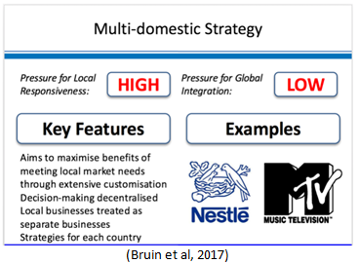

Global Strategy

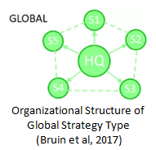
A global strategy is the exact opposite of a multi-domestic approach. Here, a business will place production efficiency above other factors, thus sacrificing responsiveness to local preferences. It is possible that minor product modifications are made within specific markets, but this strategy relies on economies of scale to gain an advantage. As a result, the firm’s products or services will essentially be identical regardless of market (Edwards, n.d.). One premise of a global strategy that is similar to a multi-domestic strategy is that corporations utilizing both approaches will have a physical presence in most, if not all, of the nations in which they conduct business (Global strategy, n.d.).
Packaged goods giant, Procter & Gamble, strives to maximize efficiency by creating global brands at every opportunity. Microsoft employs this same approach. Regardless of your global location, the Windows operating system is still the Windows operating system. However, Microsoft does provide slight variation in their product by translating their operating system into different languages. This global approach is most successfully used by firms whose product or service is not readily in the public eye, thus rendering local preference as a non-factor. Examples are makers of computer components and car parts (Edwards, n.d.).

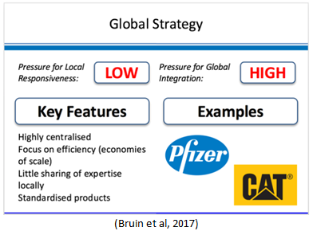

Transnational Strategy

A transnational strategy becomes more complex as it melds together portions of both a global and multi-domestic strategy. It aspires to serve local needs while still benefitting from global integration. Even though these two aims intimate opposite goals, they are certainly achievable. Corporations will create economies of scale higher in the value stream while adapting downstream activities, like sales and marketing, to local markets. Transnational companies are organized into an interdependent web of subsidiaries who each maintain a strategic role within the larger organization. Knowledge and expertise is exchanged between the subsidiary centers of excellence allowing the organization, as a whole, to meet their diversified objectives (Bruin et al, 2017).

From an organizational standpoint, much of the decision making in a transnational business is decentralized, unlike the highly centralized and controlled method used in a multinational approach. Marketing strategy, decision making, and office culture are all dictated in the country in which the country is operating. This approach can be advantageous as it allows for the organization to share and adopt best practices from a diverse array of business environments. It also allows a firm to take advantage of cheaper labor and natural resources available in more undeveloped countries. The approach does not come without risk though. A business does risk lacking a full understanding of their foreign markets and even losing control of marketing and operational continuity as the central company headquarters is not tasked with guiding all decisions within foreign markets ( Parikh, 2018).

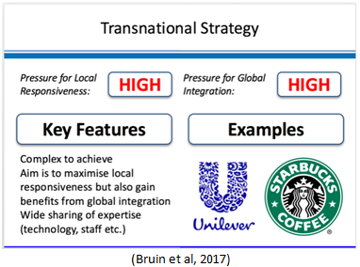

International Strategy

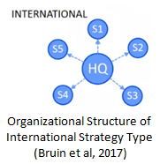
With a strong centralized headquarters exerting control over all global operations, the strategy of an international company will focus on creating value by transferring core competencies from the firm’s domestic market to new international markets. Typically, this strategy involves very little variation in product or service, instead choosing to leverage current knowledge and capabilities to gain advantage. Often, a firm employing an international strategy will decide to expand into foreign markets where their core competencies are lacking in the indigenous business, thus providing them an immediate competitive advantage to exploit. Within this strategy, the company headquarters exercises much control over decision making in international markets and retains ownership of research and development functions for the company as well. Manufacturing facilities are commonly placed with local countries to take advantage of lower costs associated with manufacturing in the local country. In addition, some local control is given when crafting marketing strategies to allow for consideration of local consumer preference.
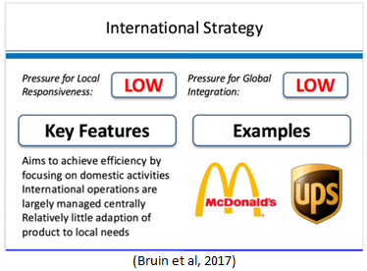

REFERENCES

Bruin, L., Marques, M., Kanani, P., & Roekel, M. (2017). International Business Strategy.

Business-to-you. Retrieved from https://www.business-to-you.com/international-

business-strategy/

Edwards, J., Kethchen, D., Short, J., Try, D. Mastering Strategic Management: Evaluation and Execution - 1st Canadian Edition. (no date) Retrieved from: https://opentextbc.ca/strategicmanagement/

Gerencer, T. How Much Money Does Walmart Make In A Year? (2016). MoneyNation.

Retrieved from http://moneynation.com/how-much-money-does-walmart-make/

Global Strategy. (no date). Market Business News. Retrieved from https://marketbusinessnews.com/financial-glossary/global-strategy/

Kia Motors. (2018). Fortune Global 500. Retrieved from http://fortune.com/global500/kia-

motors/

Llamazares, O. (2017) Dictionary of International Trade. Retrieved from

https://www.globalnegotiator.com/international-trade/dictionary/multidomestic-strategy/

Parikh, V. (2018). Advantages and Disadvantages of Transnational Strategy. LetsLearnFinance.

Retrieved from http://www.letslearnfinance.com/advantages-disadvantages-transnational-

strategy.html

Total number of stores of Walmart International in 2018, by country. (2018). Statistica. Retrieved from https://www.statista.com/statistics/269424/total-number-of-stores-of- walmart-international-by-country/

World Development Indicators database. (2018) World Bank. Retrieved from
http://databank.worldbank.org/data/download/GDP.pdf

