General Format
APA 7th edition

GENERAL APA GUIDELINES

Your essay should be typed and double-spaced on standard-sized paper (8.5" x 11"), with 1" margins on all sides. Include a page header (also known as the “running head”) at the top of every page. For a professional paper, this includes your paper title and the page number. For a student paper, this only includes the page number. To create a page header/running head, insert page numbers flush right. Then type "TITLE OF YOUR PAPER" in the header flush left using all capital letters. The running head is a shortened version of your paper's title and cannot exceed 50 characters including spacing and punctuation.

FONT

The 7th edition of the APA Publication Manual requires that the chosen font be accessible (i.e., legible) to all readers and that it be used consistently throughout the paper. It acknowledges that many font choices are legitimate, and it advises writers to check with their publishers, instructors, or institutions for guidance in cases of uncertainty.
While the APA Manual does not specify a single font or set of fonts for professional writing, it does recommend a few fonts that are widely available. These include sans serif fonts such as 11-point Calibri, 11-point Arial, and 10-point Lucida Sans Unicode as well as serif fonts such as 12-point Times New Roman, 11-point Georgia, 10-point Computer Modern.
Major Paper Sections
Your essay should include four major sections: the Title Page, Abstract, Main Body, and References.

TITLE PAGE

Note: APA 7 provides slightly different directions for formatting the title pages of professional papers (e.g., those intended for scholarly publication) and student papers (e.g., those turned in for credit in a high school or college course).
The title page should contain the title of the paper, the author's name, and the institutional affiliation. A professional paper should also include the author note. A student paper should also include the course number and name, instructor name, and assignment due date.
Type your title in upper and lowercase letters centered in the upper half of the page. The title should be centered and written in boldface. APA recommends that your title be focused and succinct and that it should not contain abbreviations or words that serve no purpose. Your title may take up one or two lines. All text on the title page, and throughout your paper, should be double-spaced.
Beneath the title, type the author's name: first name, middle initial(s), and last name. Do not use titles (Dr.) or degrees (PhD).
Beneath the author's name, type the institutional affiliation, which should indicate the location where the author(s) conducted the research.
A professional paper should include the author note beneath the institutional affiliation, in the bottom half of the title page. This should be divided up into several paragraphs, with any paragraphs that are not relevant omitted. The first paragraph should include the author’s name, the symbol for the ORCID iD, and the URL for the ORCID iD. Any authors who do not have an ORCID iD should be omitted. The second paragraph should show any change in affiliation or any deaths of the authors. The third paragraph should include any disclosures or acknowledgements, such as study registration, open practices and data sharing, disclosure of related reports and conflicts of interest, and acknowledgement of financial support and other assistance. The fourth paragraph should include contact information for the corresponding author.

A student paper should not include an author note.

Note again that page headers/page numbers (described above for professional and student papers) also appear at the top of the title page. In other words, a professional paper's title page will include the title of the paper flush left in all capitals and the page number flush right, while a student paper will only contain the page number flush right.

Student APA title page
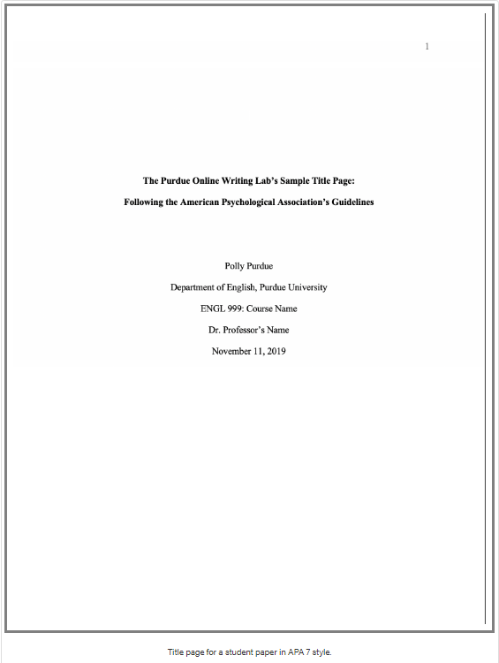

ABSTRACT

**Note – abstracts are only required on papers of more than 10 pages or if the assignment instructions specifically require one.

Begin a new page. Your abstract page should already include the page header (described above). On the first line of the abstract page, center and bold the word “Abstract” (no italics, underlining, or quotation marks).
Beginning with the next line, write a concise summary of the key points of your research. (Do not indent.) Your abstract should contain at least your research topic, research questions, participants, methods, results, data analysis, and conclusions. You may also include possible implications of your research and future work you see connected with your findings. Your abstract should be a single paragraph, double-spaced. Your abstract should typically be no more than 250 words.
You may also want to list keywords from your paper in your abstract. To do this, indent as you would if you were starting a new paragraph, type Keywords: (italicized), and then list your keywords. Listing your keywords will help researchers find your work in databases.

APA Abstract Page
